Order of Worship

Prelude Now Pray We Unto Thee Buxtehude
Welcome Pastor Warner
*Song Jesus, Lover of My Soul UMH 479
Prayer Luann Ingram
God of Grace, we give thanks that it is acceptable to be human. We rejoice that we do not have to have every answer. We praise you that you alone are God. May this season of Lent be a time to lament the sin of our world the suffering of humanity, and the travail of creation. Reassure us that you have created us “very good,” and that you forgive us when we behave badly. May our prayers be honest , trusting you to forgive, heal, and guide us. Amen.
Choir Anthem Lenten Meditation 2 Althouse
Scripture Readings 2 Corinthians 5:20b-6:10 Luann Ingram
Matthew 6:1-6,16-21
Response Luann Ingram
L: Even now, return to me with all your heart, says the Lord.
P: In this season of Lent, make God’s will our own.
L: Return to me with fasting, weeping, and mourning, says our God.
P: We bring our unanswered questions, laments, and confessions to the Holy One.
L: Return to the Lord, your God, for God is gracious and merciful.
P: Return to God who is slow to anger, and abounding in steadfast love.
L: We dedicate our thoughts, our time, and our work,
P: that this world may become whole, beginning with us.
*Song Give Me Jesus Ortega
Offering
Prayer of Confession Psalm 51:1-17 UMH 785
L: Have mercy on me, O God, according to your steadfast love;
P: according to your abundant mercy blot out my transgressions.
L: Wash me thoroughly from my iniquity, and cleanse me from my sin!
P: For I know my transgressions, and my sin is ever before me
L: Against you, you only, have I sinned, and done that which is evil in your sight, so that you are justified in your sentence and blameless in your judgement.
P: Behold, I was born into iniquity, and I have been sinful since my mother conceived me.
L: Behold, you desire truth in the inward being; therefore teach me wisdom in my secret heart.
P: Purge me with hyssop, and I shall be clean; wash me, and I shall be whiter than snow;
L: Make me hear with joy and gladness; let the bones which you have broken rejoice.
P: Hide your face from my sins, and blot out all of my iniquities.
L: Create in me a clean heart, O God, and put a new and right spirit within me.
P: Cast me not away from your presence, and take not your holy Spirit from me.
L: Restore me to the joy of your salvation, and sustain in me a willing spirit.
P: Then I will teach transgressors your ways, and sinners will return to you.
L: Deliver me from death, O God, God of my salvation, and my tongue will sing aloud of your deliverance.
P: O Lord, open my lips, and my mouth shall show forth your praise.
L: For you have no delight in sacrifice; were I to give a burnt offering, you would not be pleased.
P: The sacrifice acceptable to God is a broken spirit; a broken and contrite heart, O god, you will not despise.

*Song Jesus, Paid it All CH 305

Invitation to the Observance of Lenten Discipline
Dear brothers and sisters in Christ: Christians have always observed with great devotion the days of our Lord's passion and resurrection. It became the custom of the church to prepare for Easter by a season of penitence, fasting, and prayer. This season of forty days provided a time in which converts to the faith were prepared for baptism into the body of Christ. It is also the time when persons who had committed serious sins and had been separated from the community of faith were reconciled by penitence and forgiveness and restored to the fellowship of the church. The whole congregation is thus reminded of the mercy and forgiveness proclaimed in the gospel of Jesus Christ and the need we all have to renew our baptismal faith.
I invite you, in the name of the Lord, to observe a holy Lent, by self-examination, penitence, prayer, fasting, and almsgiving; and by reading and meditating on the Word of God. To make a right beginning, and as a mark of our mortality, let us now bow before God who is our Creator and Redeemer.
Communion & Imposition of Ashes
Blessing of the Bread and Cup
Lord’s Prayer
Sharing the Bread and the Cup

Imposition of Ashes
(Remember you are dust, and to dust you shall return
Repent, and believe the gospel.)

Silent Reflection and Prayer
You are invited to spend time at the altar or in the pew in prayer. Please exit the Sanctuary in silence in respect for others who may still be praying and reflecting.
Worship Leaders
Pastor Steward Warner
Luann Ingram
Lansdale United Methodist Church
300 N. Broad Street
Lansdale, PA 19446
Office email: office@lansdaleumc.org
Office phone: 215-855-8364
Lansdale United Methodist Church

Ash Wednesday
Communion | Imposition of Ashes

February 14, 2024
7 PM

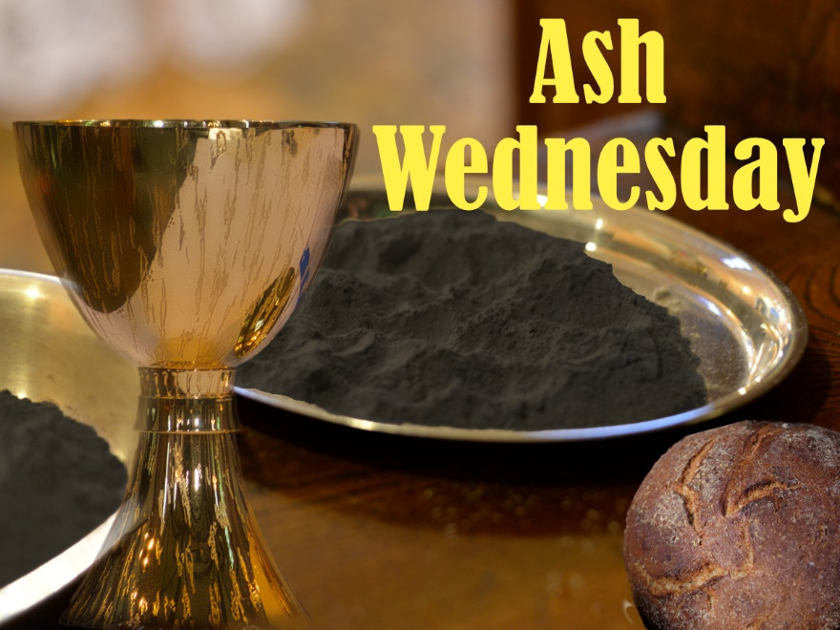

Our Mission
Praising God ● Making Disciples ● Serving All
Join us for online worship!
Livestreamed on Sundays at 9am
YouTube: Lansdale UMC
Facebook: Facebook.com/Lansdale-United-Methodist-Church Website: https://lansdaleumc.org

