Order of Worship
7:00 p.m. Live Stream and In-Person Worship Service

Prelude Beneath the Cross of Jesus UMH 297 (quartet)
Greetings & Announcements Pastor Warner
*Call to Worship Koshy John Thalakal
L: Remember the saving love of God, for Christ claims us as
his own.
P: Gratitude calls us here.
L: Come to the table of grace. Eat of the bread of life, and drink from the cup of salvation.
P: Wonder invites us to go deeper.
L: Ponder the depth of Christ’s love, as he washes the feet
of his disciples.
P: Love leads us home.
*Song Hallelujah, What a Savior! UMH 165
(Ushers will collect prayer cards during the hymn)
Opening Prayer
O God, our failings are ever before us. We feel crushed under their weight. Yet in your eyes, Holy One, we remain beloved children created in the glory of your image. Help us see ourselves as you see us. Only then will we fully accept the gift of grace Christ offers us on this holy day. Amen.
Old Testament Reading Exodus 12:1-14 Koshy John Thalakal

Choir Anthem Wondrous Love Tucker/Cameron
Call to Giving
(Your giving to LUMC makes ministry possible in our community and around the
world! Thank you! You can give online at: https://lansdaleumc.org/giving/ )

Song Jesus Remember Me UMH 488
*Doxology UMH 95
*Offering Prayer

Sacrament of Holy Communion
L: The Lord be with you
P: And also with you
L: Lift up your hearts
P: We lift them to the lord
L: Let us give thanks to the Lord our God
P: It is right to give our thanks and praise
L: It is right…their unending hymn
P: Holy, holy, holy Lord, God of power and might, heaven and earth are full of your glory. Hosanna in the highest. Blessed is he who comes in the name of the Lord. Hosanna in the highest
L: Holy are you… the mystery of faith
P: Christ has died, Christ is risen, Christ will come again.
L: Pour out your Holy Spirit… All honor and glory is yours
Almighty Father, now and forever Amen.
P: Amen
The Lord’s Prayer No. 895
Tenebrae Drama
Stripping of the altar
Tenebrae is the Latin word for “darkness”. This is an adaptation of a service that dates back to the ninth century.
The candles represent Jesus and his twelve disciples. Each extinguished candle represents another disciple deserting Jesus before his crucifixion.
Remembering Jesus’ final hours.
Please leave in silence after the Christ candle has returned to the sanctuary.
Lay Reader…………………………….……Koshy John Thalakal
Acolyte………………………………………………...Emma Weiss
Readers…………………………………………………..Zoeh John
Pastor Steward Warner
Thank you to Mark Reinmiller, for making the Tenebrae Candle Stand.

Children’s Easter Egg Hunt & Light Breakfast!
Come out and join us, as we host a Children’s Easter Egg Hunt and breakfast. This is open to everyone! Please invite your friends & neighbors. It will take place this Saturday April 8th. We are asking for donations of individually wrapped candies, stickers, or small toys to fill plastic eggs. Do you have any empty plastic eggs laying around the house? Please donate them for our egg hunt. There will be a 2nd container for plastic egg donations. Set up for the egg hunt and breakfast will be tomorrow Friday, April 7th at 1:00 PM. The eggs will be filled at that time. Registration links are available on the Church Website (see the attached link) Lent & Easter – Lansdale United Methodist Church (lansdaleumc.org)

Please join us in celebrating Jesus’ resurrection on Easter Sunday 4/9 at 9 AM. The Brass Band will be playing. Worship will conclude with singing of the Hallelujah Chorus.
Lansdale United Methodist Church
Praising God – Making Disciples – Serving All
300 N. Broad St, Lansdale, PA 19446
Phone: 215-855-8364
Email: office@lansdaleumc.org • Website: https:// lansdaleumc.org
Office Hours: Monday, Tuesday , Thursday , Friday 9 AM – 1PM | Wednesday 12:00 PM– 4:00 PM
Servants
Ministers – People of God
Bishop John Schol
District Superintendent – Rev. Dr. Andrew Foster
Lead Pastor – Rev. Steward Warner
stewwarner@outlook.com – 215-990-4581 (cell)

Leadership  Paul Bonner – Lay Leader  Kris Neild – Church Council Chair  Darren Johnson – Treasurer  Bob Kennedy – Trustee President  Michelle Johnson – Staff Parish Relations Chair | Staff  Ally Hediger- Administrative Assistant  Liz Bonner – Director of Christian Education  Rays Koshy – Music Director  Ruth Rineer – Organist  Paul Bonner - Custodian  Donna Fritz- Nursery Attendant
Lansdale United Methodist Church

April 6, 2023
7 PM

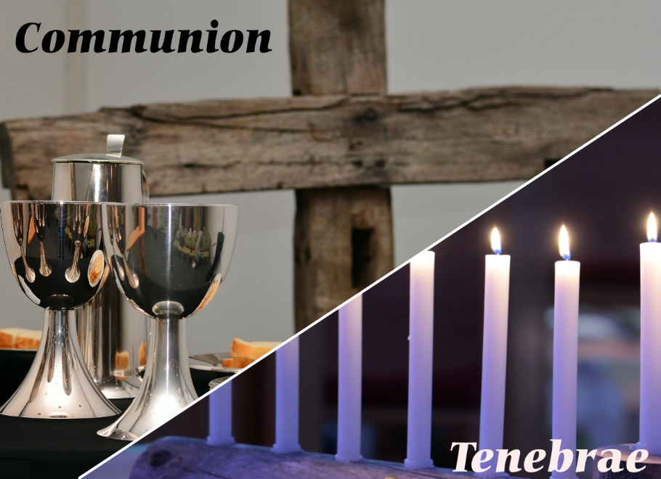

Our Mission
Praising God ● Making Disciples ● Serving All

Join us for online worship!
Livestreamed on Sundays at 9 AM

YouTube: Lansdale UMC
Facebook: Facebook.com/Lansdale-United-Methodist-Church

